|  |  |  |  |
| --- | --- | --- | --- |
| **Name:** | Jericho Tabingo Lagang | **Date:** | 15/09/2023 |
| **Program:** | BSCpE | **Section:** | A361 |

**Intended Learning Outcomes:**

# Create output with JavaScript.

1. Utilize JavaScript variables and data types.

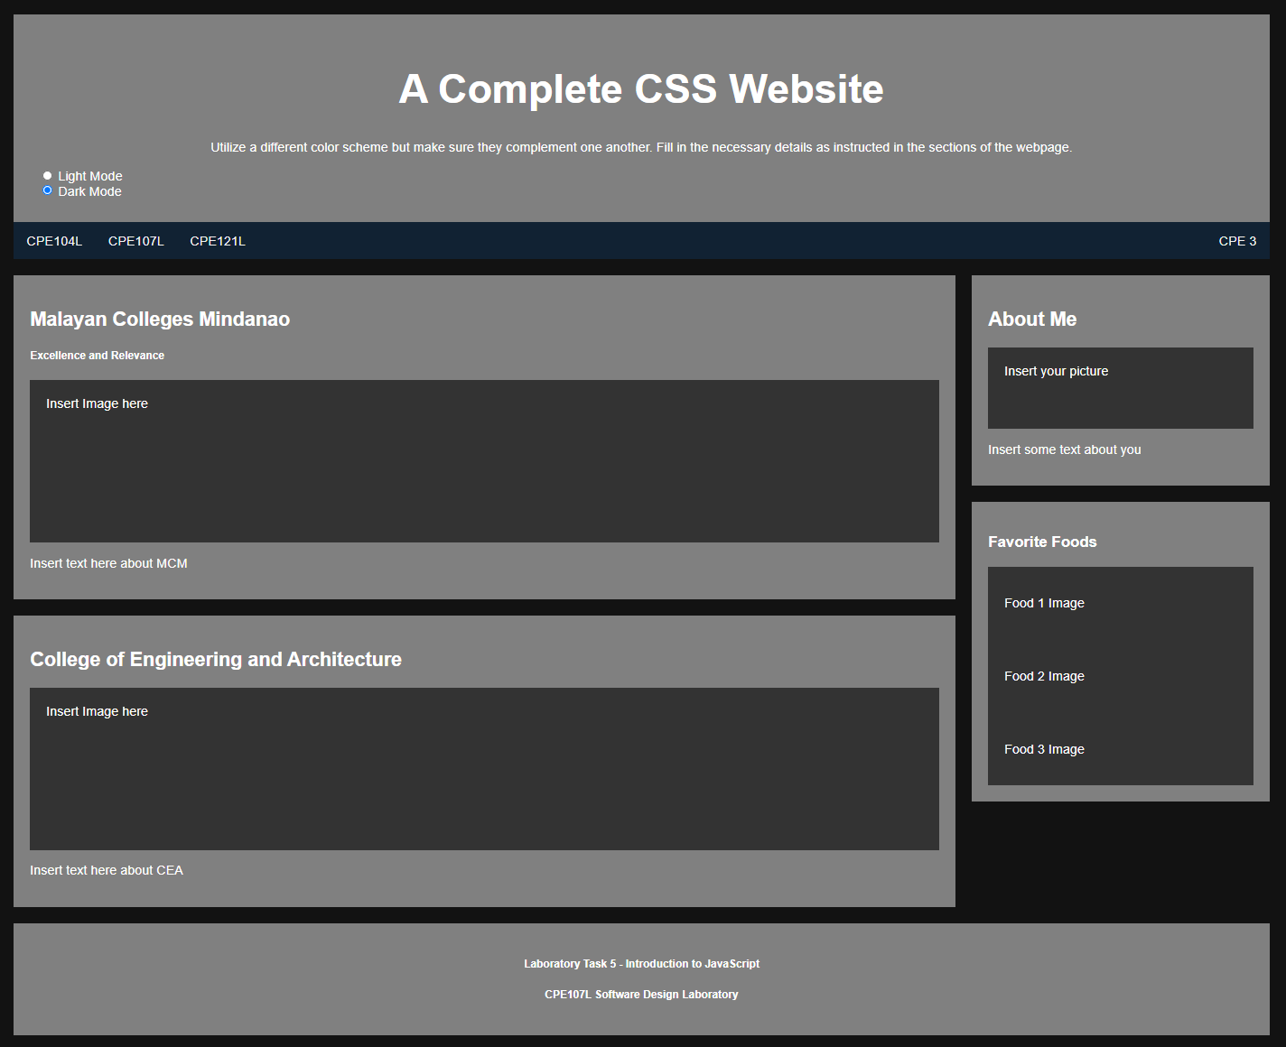

Using your output from Laboratory Task 4, include a button/check box/radio button/toggle switch that will change your website into **DARK MODE**. Here is an example output:

**CPE143L Web Design and Development**

================================================================================

**HTML Source Code:**

<!DOCTYPE html>

<html>

<head>

<link rel="stylesheet" href="CSSWeb.css">

<script src="CSSWeb.js"></script>

<title>

A Complete CSS Website

</title>

</head>

<body>

<header>

<h1>A Complete CSS Website</h1>

<p class="subtitle">Utilize a different color scheme but make sure they complement one another.

Fill in the necessary details as instructed in the sections of the webpage</p>

<input type="checkbox" id="darkModeToggle">

<label for="darkModeToggle"></label>

</header>

<nav>

<a href="" >CPE107L</a> &nbsp; &nbsp;

<a href="" >CPE143L</a>

<a id= spacedLink href="" >CPE 3</a>

</nav>

<section>

<div class="block">

<h1>Malayan Colleges Mindanao</h1>

<p>Excellence and Relevance</p>

<img src="Assets/01.jpg" width="1000" height="500" alt="Centered Image" style="display: block; margin: 0 auto;">

<br>

<br>

<caption>Mapúa Malayan Colleges Mindanao shall be a school of global standards and of great significance locally and beyond,

shall provide a learning environment in order for its students to acquire the attributes that will make them globally

competitive & locally in-demand, shall engage in cutting edge and economically viable research, development and innovation

that is relevant locally and beyond, and shall provide state-of-the-art solutions to problems of industries and

communities locally and beyond.

</caption>

</div>

<div class="block">

<h1>College of Engineering and Architecture</h1>

<img src="Assets/02.jpeg" width="750" height="450" alt="Centered Image" style="display: block; margin: 0 auto;">

<br>

<br>

<caption>College of Engineering and Architecture (CEA) transforms its graduates to become globally competitive, innovative

leaders, socially responsible and result-oriented engineers and architects. MapúaMCM-CEA commits to educate students

imbued with good moral and ethical values while engaging economically viable research and innovation that is relevant

locally and beyond. </caption>

</div>

<div class="clear"></div>

</section>

<aside>

<div class="block">

<h1>About Me</h1>

<img src="Assets/03.jpg" width="350" height="400" alt="Centered Image" style="display: block; margin: 0 auto;">

<br>

<br>

<caption>I am Jericho Tabingo Lagang, currently studying Computer Engineering at Mapúa Malayan Colleges Mindanao.

My goal is to explore the realm of technology and innovation to contribute to the progress and improvement of our world.</caption>

</div>

<div class="block">

<h1>Favorite Foods</h1>

<ul>

<li><img src="Assets/04.jpg" width="250" height="180"></li>

<li><img src="Assets/05.jpg" width="250" height="180"></li>

<li><img src="Assets/06.webp" width="250" height="180" ></li>

</ul>

</aside>

</div>

<div class="clear"></div>

</aside>

<footer class="block">

<p>Laboratory Task 5- Introduction to JavaScript</p>

<p>CPE143L Web Design and Development Laboratory</p>

</footer>

</body>

</html>

**CSS Source Code:**

html, body {

height: 140%;

margin: 0;

padding: 0;

background-color: #eaf4d3;

}

header {

text-align: center;

font-family: Arial;

padding-top: 20px;

}

header h1 {

font-size: 50px;

font-weight: bold;

color: #ca907e;

}

nav {

background-color: #ca907e;

height: 30px;

padding: 10px;

display: flex;

align-items: center;

}

nav a {

color: black;

text-decoration: none;

display: flex;

}

#spacedLink {

margin-left: auto;

}

section {

float: left;

width: 65%;

margin-left: 30px;

margin-top: 20px;

}

aside {

float: right;

width: 30%;

margin-top: 20px;

margin-right: 30px;

}

.block {

background-color: #dbd8ae;

padding: 30px;

margin-bottom: 10px;

margin-top: 10px;

}

.clear {

clear: both;

}

caption {

text-align: center;

}

ul {

list-style-type: none;

}

input[type="checkbox"] {

display: none;

}

label[for="darkModeToggle"] {

display: inline-block;

width: 60px;

height: 34px;

background-color: #ccc;

border-radius: 17px;

position: absolute;

cursor: pointer;

transition: background-color 0.3s ease;

top: 20px;

right: 50px;

padding: 0;

}

label[for="darkModeToggle"]::after {

content: "";

position: absolute;

width: 30px;

height: 30px;

border-radius: 50%;

background-color: #fff;

top: 2px;

left: 2px;

transition: transform 0.3s ease;

}

input[type="checkbox"]:checked + label[for="darkModeToggle"] {

background-color: #007bff;

}

input[type="checkbox"]:checked + label[for="darkModeToggle"]::after {

transform: translateX(26px);

}

/* Styles for dark mode */

html.dark-mode, body.dark-mode {

background-color: #333;

color: #fff;

}

.dark-mode .block {

background-color: black;

}

footer {

text-align: center;

margin-bottom: auto;

height: 200px;

background-color: #dbd8ae;

margin: 30px;

justify-content: center;

display: flex;

flex-direction: column;

justify-content: center;

align-items: center;

}

**JavaScript Source Code:**

document.addEventListener("DOMContentLoaded", function () {

const darkModeToggle = document.getElementById("darkModeToggle");

const body = document.body;

// Check if dark mode is enabled in local storage

if (localStorage.getItem("darkMode") === "enabled") {

body.classList.add("dark-mode");

darkModeToggle.checked = true;

}

// Toggle dark mode

darkModeToggle.addEventListener("change", () => {

if (darkModeToggle.checked) {

body.classList.add("dark-mode");

localStorage.setItem("darkMode", "enabled");

} else {

body.classList.remove("dark-mode");

localStorage.setItem("darkMode", "disabled");

}

});

});

**Output:**

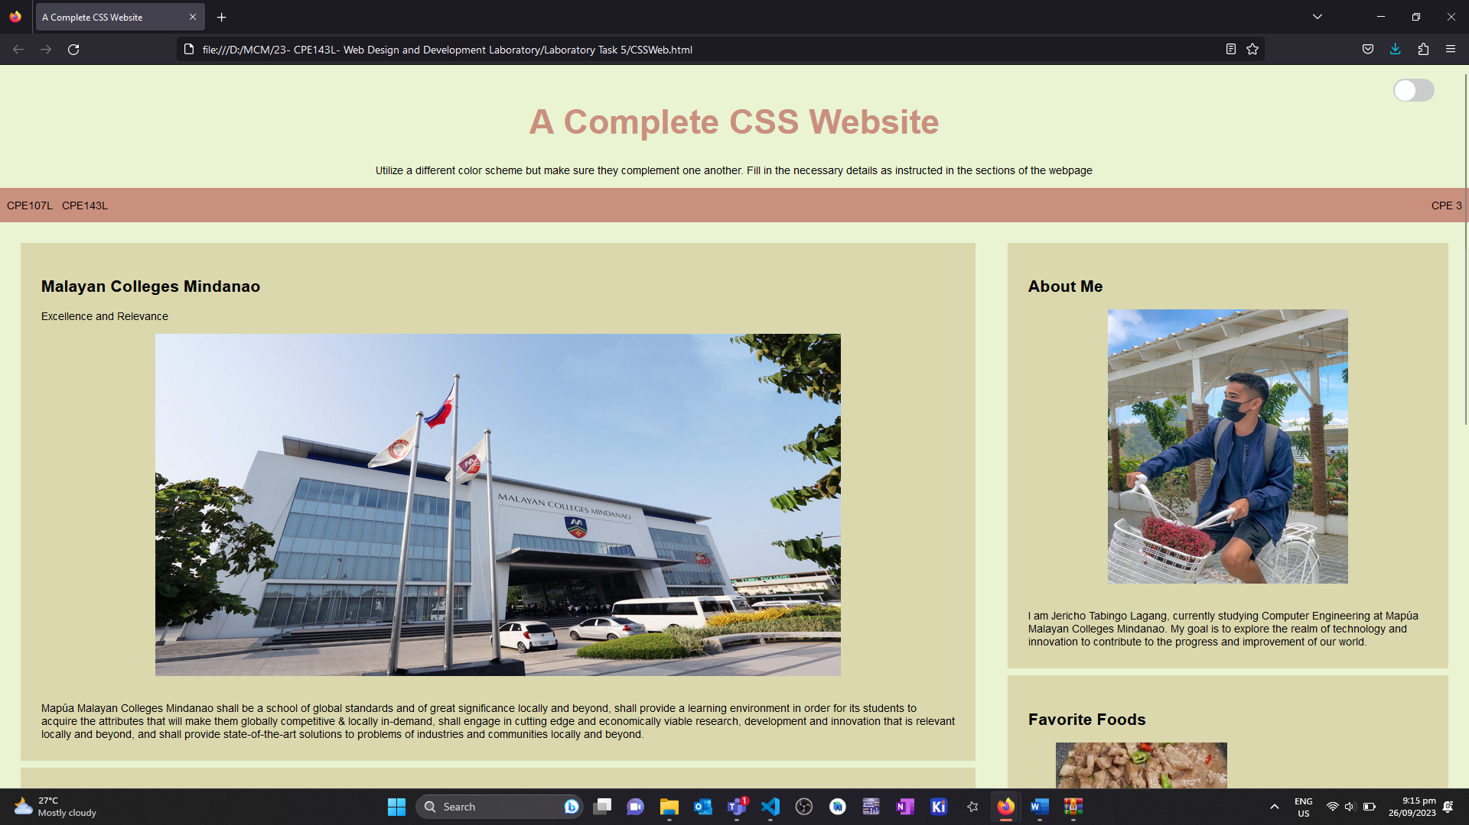

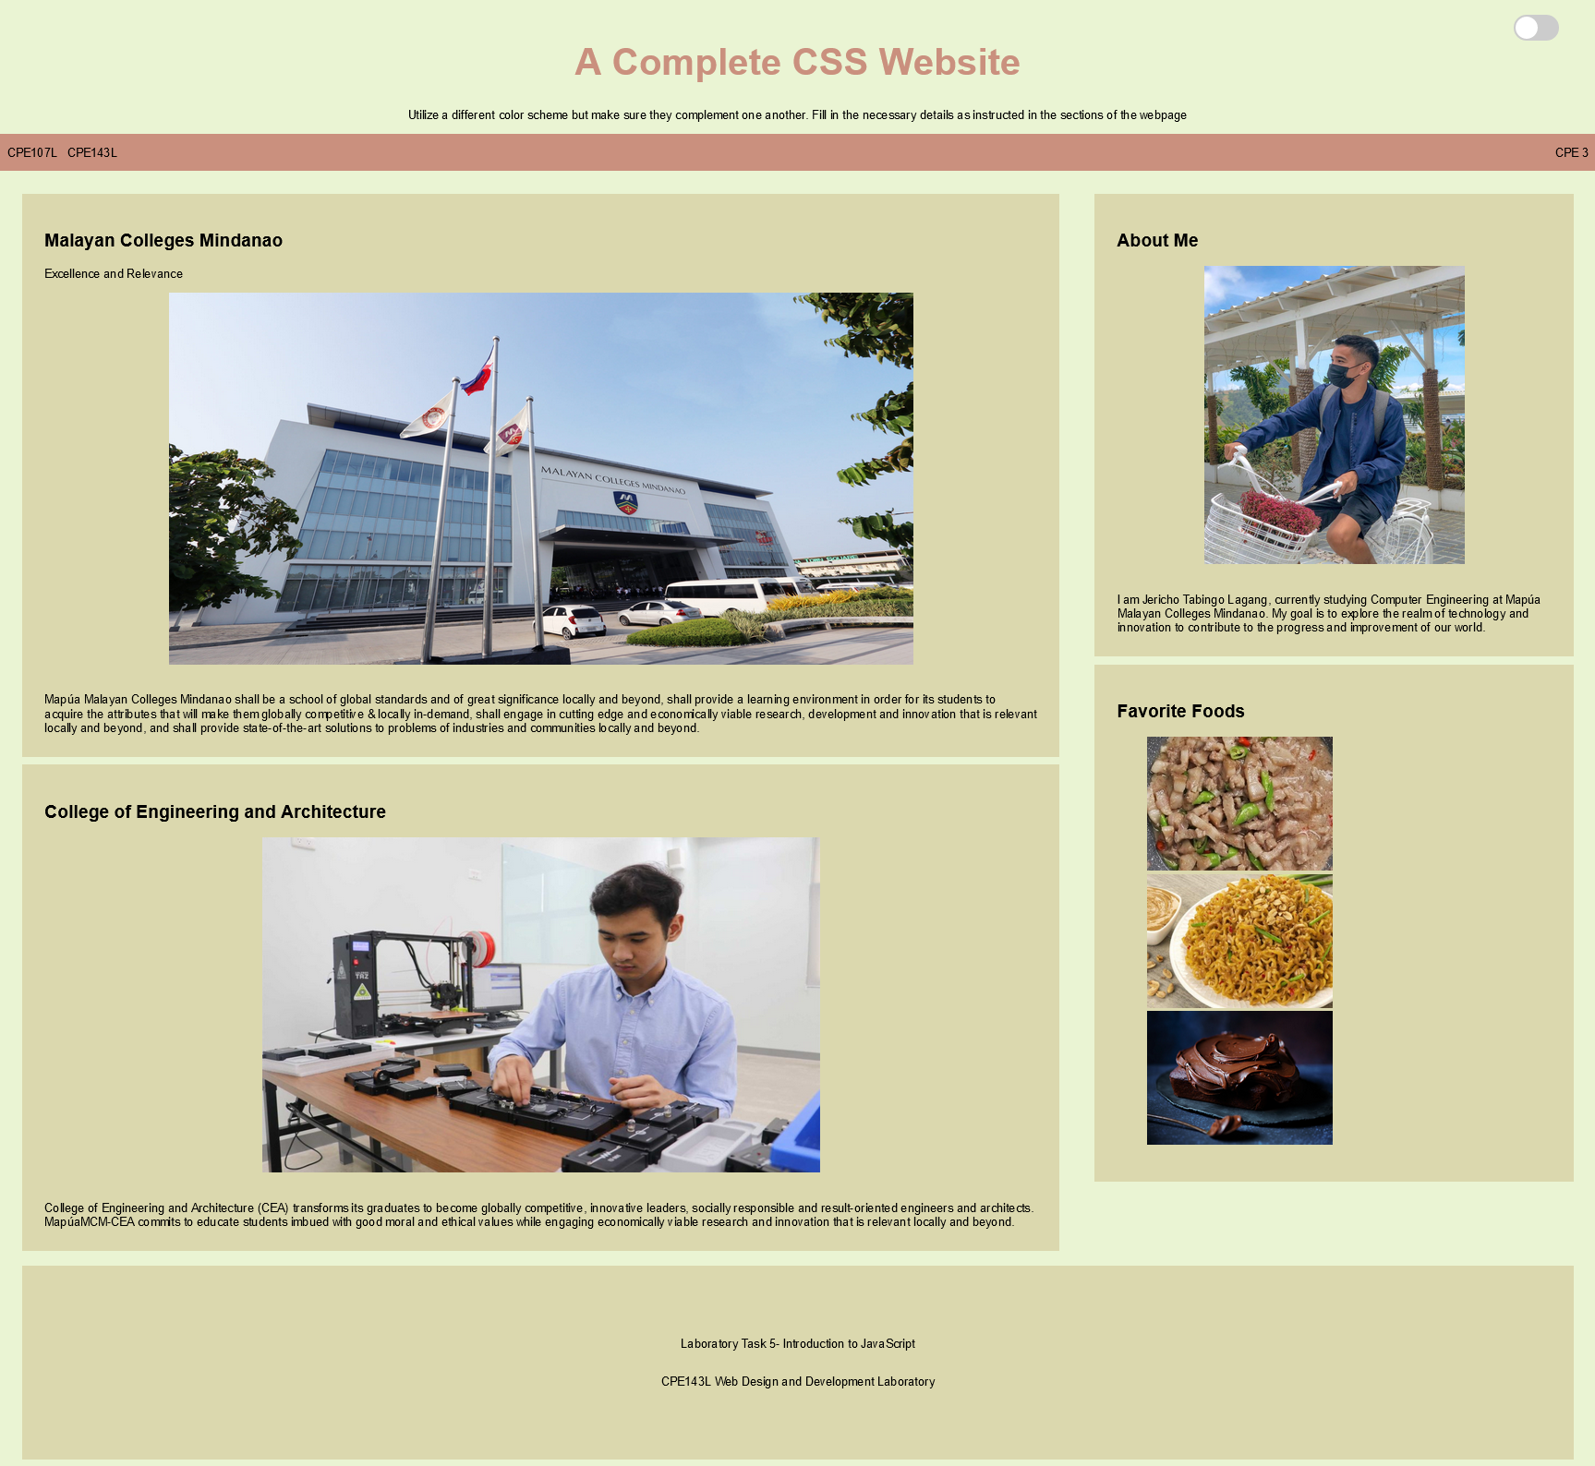

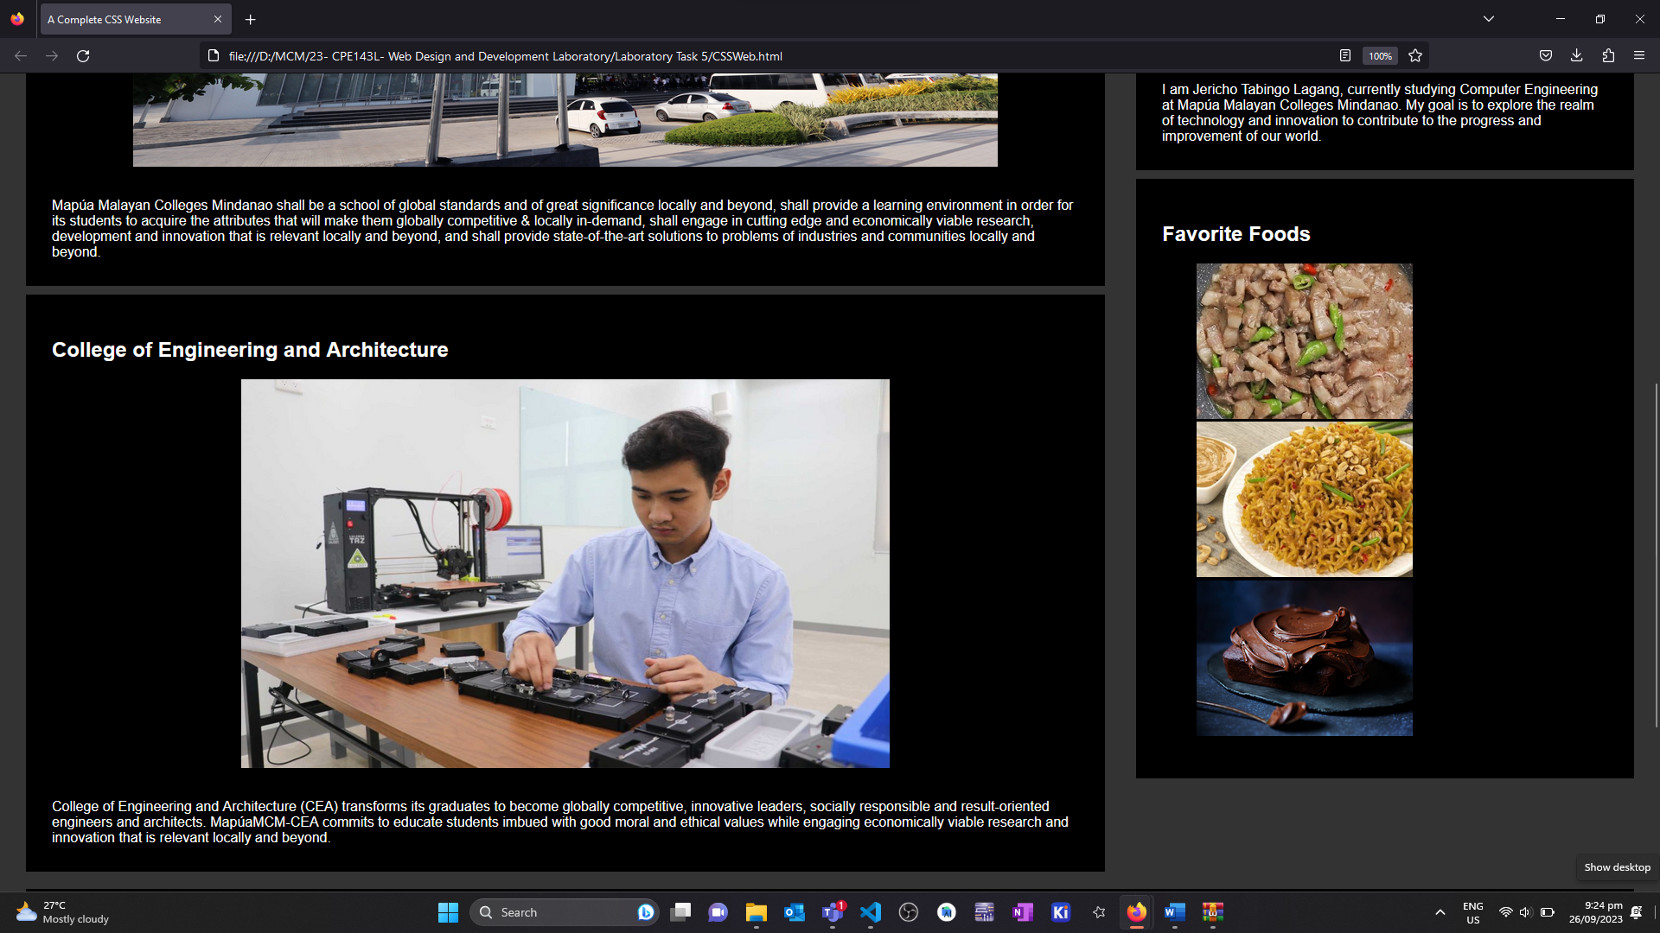

**Findings and Observations:**

The implementation of dark mode in web applications, facilitated by JavaScript, enhances user experience by providing an eye-friendly, low-light interface. By toggling CSS classes and utilizing event listeners, JavaScript dynamically adjusts the color scheme, making content more accessible and reducing eye strain. This feature, often customized to align with the website's theme, respects user preferences and can be stored in ‘localStorage’ for consistency across sessions, underscoring the importance of JavaScript in creating interactive and user-centric web experiences.